PHYTHON ASSIGNMENT

Question 2)

Result: 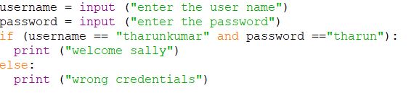

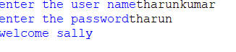

QUESTION 3)

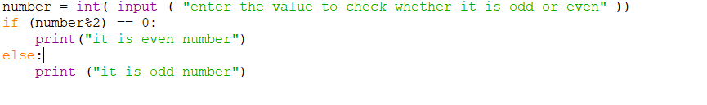

Result:



QUESTION 4)

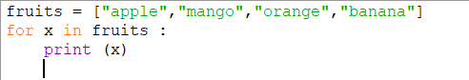

Result:

